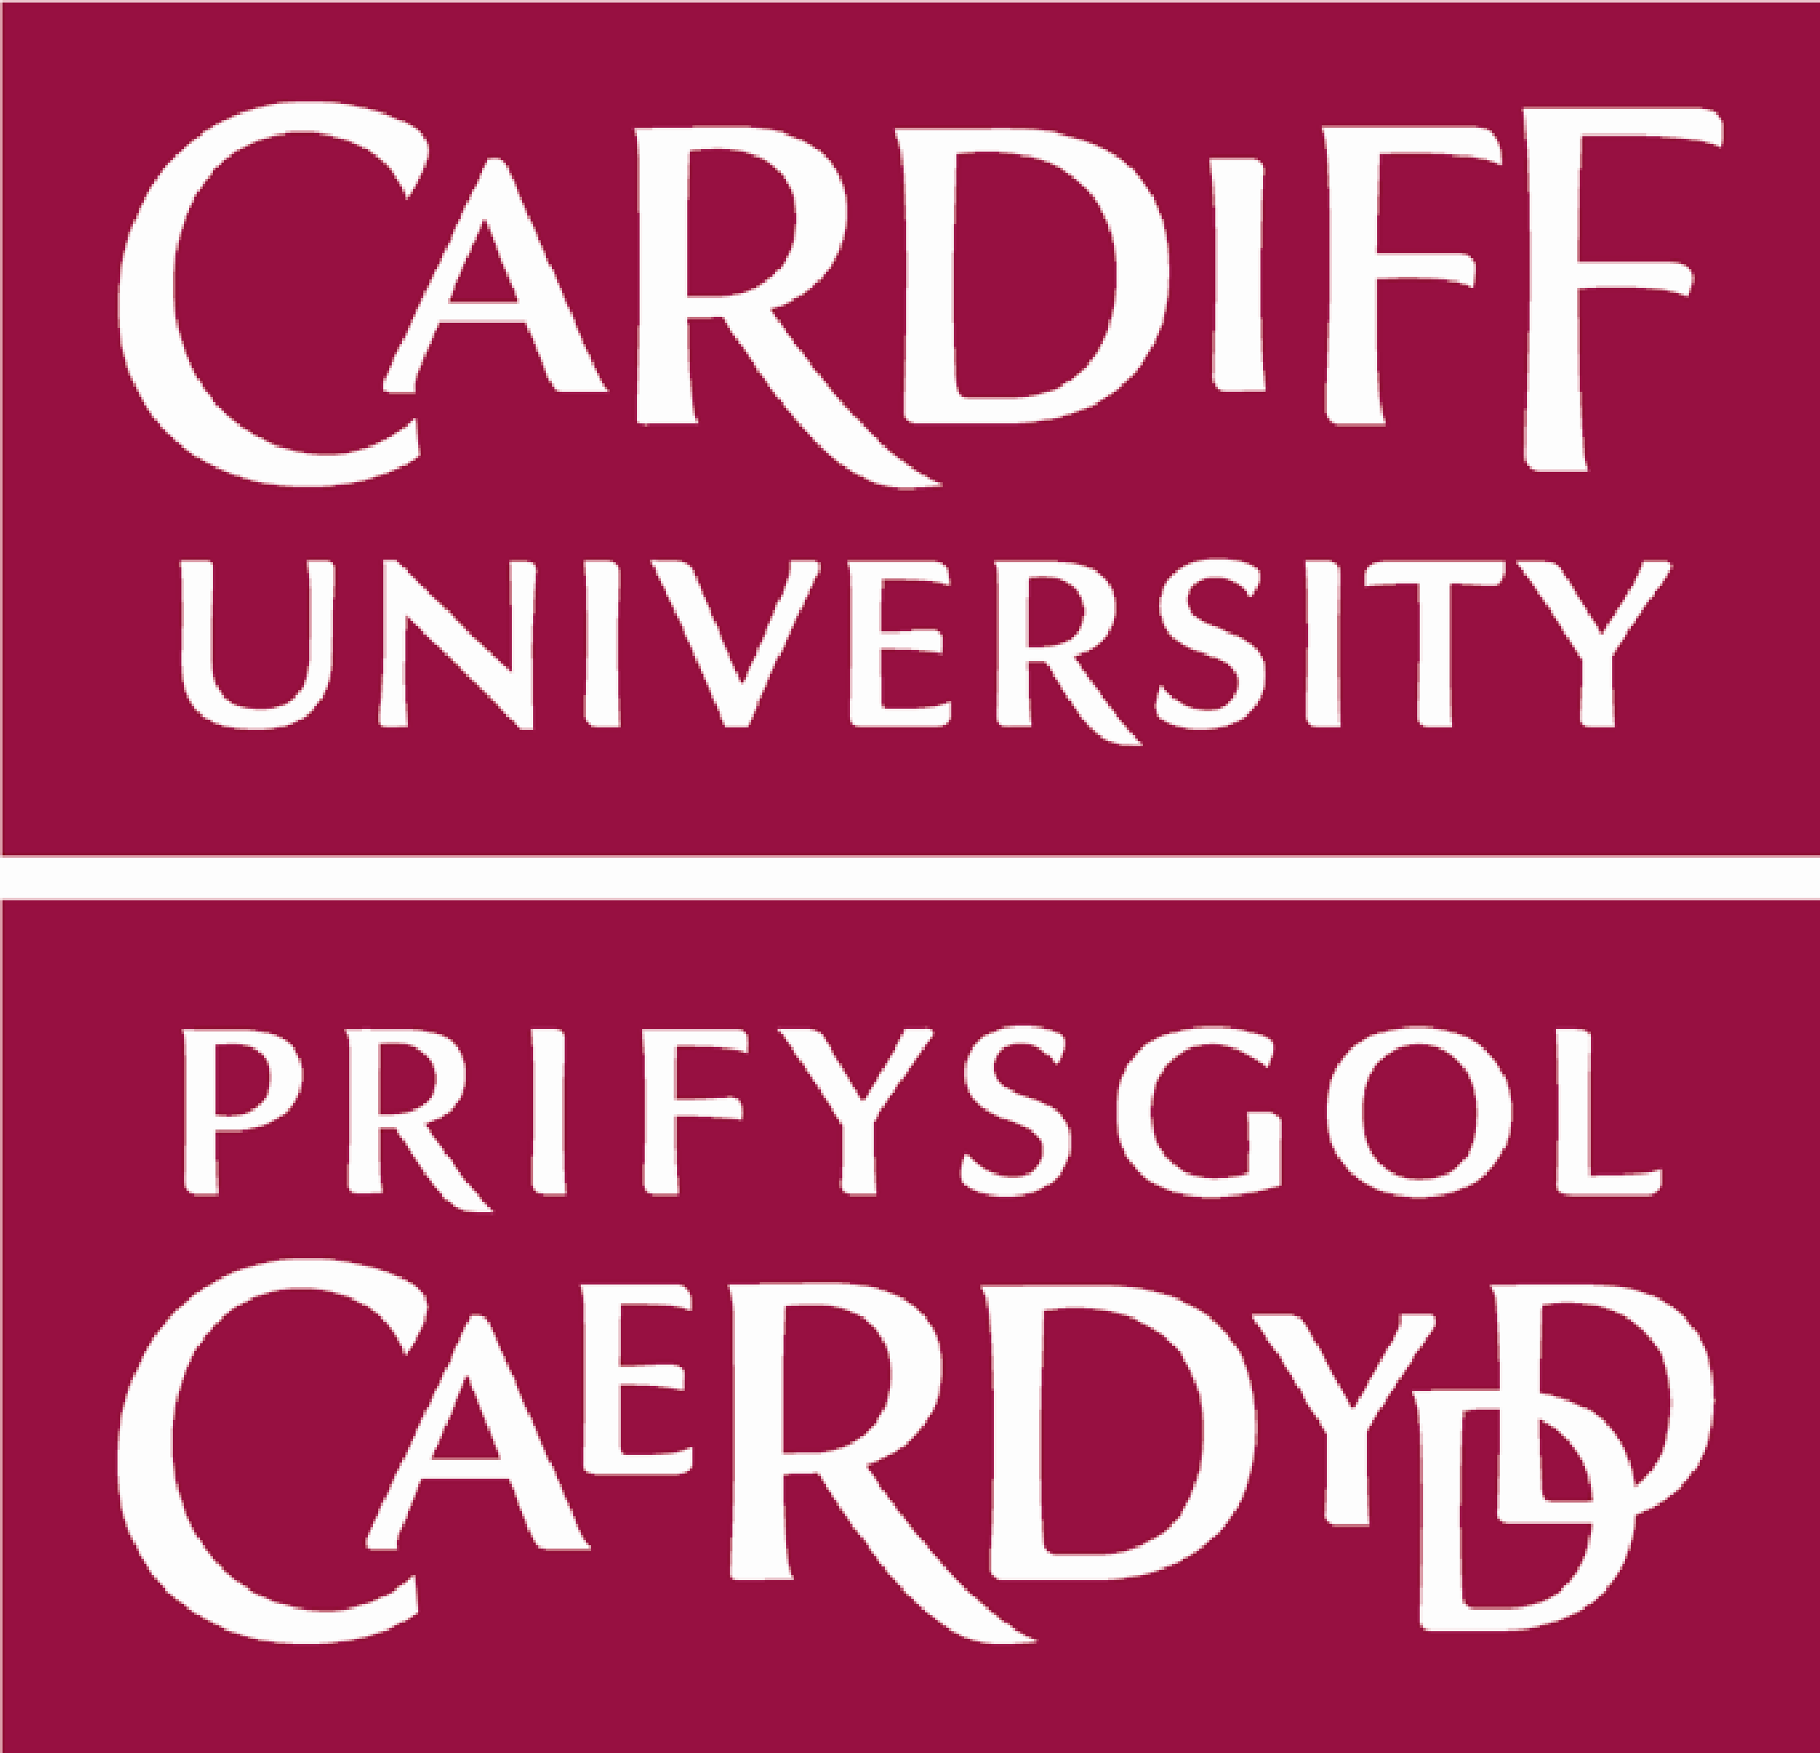
PROGRAMME
Seventh British Patristics Conference, Cardiff, 5-7 September 2018
Wednesday 5 September | Wednesday, 5 September 2018
15.00-17.00 | Arrival and Registration – Cardiff University, Main Building  Park Place, Viriamu Jones Gallery
17.00-18.30 | Opening Lecture – Wallace Lecture Theatre  Dr Sara Parvis, Edinburgh  “A Tale of Two Councils – Constantinople 360 and 381”  Followed by wine reception – Viriamu Jones Gallery
Thursday 6 September | Thursday, 6 September 2018
Room | Room 1.25 Main Building |  | Room 1.40 Main Building – Beverton LT
Panel | Early Christianity and Ancient Philosophy |  | Augustine and Manichaeism
Chair | Josef Lössl |  | Nicholas Baker-Brian
9.30-10.15 | Simeon R. Burke, University of Edinburgh  Early Christian Ethical Reading of Synoptic Anecdotes: A Contribution to the Understanding of Early Roman Morality |  | Phillip Brown, University of Nottingham  “Figurabat ecclesiam”: Friendship, Figuration and the Unity of the Church in Augustine’s 6th Tractate on John
10.15-11.00 | D. L. Dusenbury, KU Leuven  The World City: A Reconstruction of Nemesius of Emesa’s De Natura Hominis |  | Georgiana Huian, University of Bern  “…In the synagogue of gods”: Augustine’s Notion of Deification in Sermon 23B (Mainz 13)
11.00-11.30 | Tea and Coffee Break – Viriamu Jones Gallery
Room | Room 1.25 Main Building | Room 1.40 Main Building – Beverton LT
Panel | Early Christianity and Ancient Philosophy (Continued) | Augustine and Manichaeism (Continued)
Chair | Markus Vinzent | Nicholas Baker-Brian
11.30-12.15 | Ilaria Ramelli, Catholic University of Milan  The Logos/Nous One-Many between “Pagan” and Christian Platonism: Bardaisan, Clement, Origen, Plotinus, and Gregory of Nyssa |  | Susanne Towers, Cardiff University  Methods and Misconceptions: Approaching the Study of Gender in Manichaeism
12.15-13.00 | Inbar Graiver, Humboldt-Universität Berlin  The Late Antique Roots of Introspection |  | Math Osseforth, Camphusianum, The Netherlands  Augustine in the Underworld: An Example of Intertextuality in Augustine’s Confessions
13.00-14.00 | Lunch Break  Thursday, 6 September (Continued)
Room | Room 1.25 Main Building | Room 1.40 Main Building – Beverton LT
Panel | Cappadocians |  | Monasticism and Asceticism
Chair | Gillian Clark |  | Alex McAuley
14.00-14.45 | Isabella Sandwell, University of Bristol  Gregory of Nyssa on the Father’s Progeneration of the Son in his Against Eunomius: Evidence of Engagement with the Conceptual Metaphor “Causation is Progeneration” |  | Jonathan L. Zecher, Australian Catholic University  The (Well-Mannered) Physician of Souls: Ethics and Comportment in Galenic and Monastic Literature
14.45-15.30 | Emma Dewhurst, University of Edinburgh  Gregory of Nyssa on the Soul and the Cyberpunk Future |  | Daniel Lemeni, West University of Timisoara  Ascetic Clothing and Spiritual Authority in Late Antique Monasticism
15.30-16.00 | Tea and Coffee Break – Viriamu Jones Gallery
Room | Room 1.25 Main Building | Room 1.40 Main Building – Beverton LT
Panel | Cappadocians (Continued) |  | Antiochene Authors
Chair | Gillian Clark |  | Alex McAuley
16.00-16.45 | Theoni Mpoura, Greece  Gregory of Nyssa, “On the Soul and the Resurrection”: The Items, the Influences and the Relation with the Socratic Dialogue |  | Douglas Finn, Boston College  Chrysostom’s Preaching on Job and His Illness
16.45-17.30 | Olga Alieva, Moscow, National Research University, HSE  Theology as Christian Epopteia in St. Basil of Caesarea |  | Luise Frenkel, Max-Weber-Kolleg, Universität Erfurt  The Historiography of Imperial Advisors: Eusebius of Caesarea and Theodoret of Cyrrhus against the Consensus
18.00-19.30 | Plenary Lecture – Main Council Chamber  Professor Tom O’Loughlin, Nottingham  “Christianity in the Late Antique Latin West”  Followed by Banquet – Jury’s Inn Hotel  ***
Friday  7 September | Friday, 7 September 2018
Room | Main Council Chamber | Room 1.40 Main Building – Beverton LT
Panel | Cappadocians (Continued) |  | Syriac Authors
Chair | Tom O’Loughlin |  | Sara Parvis
9.30-10.15 | Robin Orton, King’s College London  Gregory of Nyssa on the Creation of the World: Theology and Science in In Hexaemeron |  | Michael Muthreich, Göttingen Academy of Sciences and Humanities  The Second Dionysian Text in ms. “Vat. Sir. 123”
Friday, 7 September | Friday, 7 September (Continued)
Room | Main Council Chamber |  | Room 1.40 Main Building – Beverton LT
Panel | Cappadocians (Continued) |  | Second and Third Century
Chair | Tom O’Loughlin |  | Sara Parvis
10.15-11.00 | Alexandre Siniakov, Orthodox Seminary of Paris  Gregory of Nazianzus in the Byzantine Liturgical Hymnography |  | Awet Andemicael, Yale  Irenaeus’ Political Theology and the Ecclesial Recapitulation of the State
11.00-11.30 | Tea and Coffee Break – Viriamu Jones Gallery
Room | Main Council Chamber | Room 1.40 Main Building – Beverton LT
Panel | Cappadocians (Continued) | Second and Third Century (Continued)
Chair | Tom O’Loughlin | Sara Parvis
11.30-12.15 | James F. Wellington  Subverting Subversion: An Ontological Reading of Gregory of Nyssa’s Refutation of Slavery in In Ecclesiasten Homiliae IV |  | Phoebe Kearns, University of Winchester  Liturgical Expression of Trinitarian Theology in Third Century Antioch
 |  |  | Fourth Century
12.15-13.00 | Yulia Rozumna, University of Nottingham  Relationship between Divine Grace and Human Efforts in the Process of Salvation and Purification of Passions |  | Zachary Esterson, Cardiff University  Land of the Apocalypse: The Pannonian Context of Victorinus of Pettau’s Commentary on Revelation
13.00-13.45 | Lunch Break – Viriamu Jones Gallery
13.45-14.30 | Plenary Meeting / Planning – Main Council Chamber
Room | Room 1.25 Main Building |  | Room 1.40 Main Building – Beverton LT
Panel | Later Fathers and Reception |  | Fourth Century (Continued)
Chair | Bella Sandwell |  | Nicholas Baker-Brian
14.45-15.30 | Steve Duby, Grand Canyon University, Arizona  “True God from True God”: The Father’s Communication of the Divine Essence (with reference to Peter Lombard and Thomas Aquinas) |  | Kirsten H. Mackerras, University of Oxford  Pieties in Conflict: Lactantius, Porphyry and the Latin Panegyrics
15.30-16.15 | Ewan King  “Blessed Radiance”: Transfiguration, Divinisation and Exegesis in Ambigua 10 |  | Eirini Artemi, Hebrew University, Jerusalem  The “Logos” in the Teaching of Marcellus of Ancyra and Sabellius
16.15-16.45 | Tea and Coffee Break – Viriamu Jones Gallery
 | Friday, 7 September (Continued)
Room | Room 1.25 Main Building |  | Room 1.40 Main Building – Beverton LT
Panel | Later Fathers and Reception (Continued) |  | Latin Fourth and Fifth Century
Chair | Bella Sandwell |  | Nicholas Baker-Brian
16.45-17.30 | Andrej Kutarna, University of South Bohemia  Human Will and Divine Grace: Damascene’s Teaching on Theosis and its Echo in Aquinas |  | Thomas Tsartsidis, University of Thessaly  Vergil as a Christian Exegete in the Paradisiac Landscape of Prudentius’ Cathemerinon 5
17.30-18.15 | Giorgios Siskos, Aristotle University, Thessaloniki  Identical foundations on opposite Christologies: Nestorius of Constantinople and Severus of Antioch. The critique of Saint Maximus the Confessor |  | Marcin Wysocki, KUL Lublin  How to Survive the End of the World? A Study of Latin Christian Letters of the 4th and 5th Centuries
18.15-18.30 | Farewell

